Ex. No. 2 | Class Diagram
Date of Exercise | 17-01-2017

Aim
To draw a class diagram for on-line railway reservation system
Youtube link : https://youtu.be/d8_H6d_MJJw
Description
Class diagrams identify the class structure of a system, including the properties and methods of each class. It specifies the various relationships that can exist between classes, such as an inheritance. The Class diagram is one of the most widely used diagrams from the UML specification. Part of the popularity of Class diagrams is the fact that many CASE tools, such as Rationale Rose, will provide clarity of the designing process.
The basic components on a Class diagram are classes and the relationships between them.

Class
A class is depicted using a rectangle divided into 3 sections. The top section is the name of the class. The middle section defines the properties of the class. The bottom section lists the methods of the class.
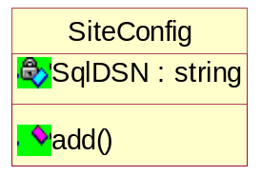

Association
An Association is a generic relationship between two classes, and is modeled by a line connecting the two classes. This line can be qualified with the type of relationship, and can also feature multiplicity rules (for eg. One-to-one, one-to-many, many-to-many) for the relationship.

Composition
If a class cannot exist by itself, and instead must be a member of another class, then that class has a Composition relationship with the containing class. A composition relationship is indicated by a line with a filled diamond.

Dependency
A Dependency relationship is indicated by a dotted arrow.
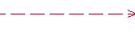

Aggregation
Aggregations indicate a whole-part relationship and are known as “has-a” relationships. An Aggregation relationship is indicated by a line with a hollow diamond.

Generalization
A Generalization relationship is the equivalent of an inheritance relationship in object-oriented terms. (“is-a” relationship). A Generalization relationship is indicated by an arrow with a hollow arrow head pointing to the base or “parent” class.

Scenario of the application
The class diagrams includes the actors and classed needed for the development of the on-line railway reservation system. The actors are defined as classed with attributes and operations. This allows them to perform different functions on to the services provided to them. The operations are converted to the class structure and are linked depending on their relationship.

Class Diagram for the application
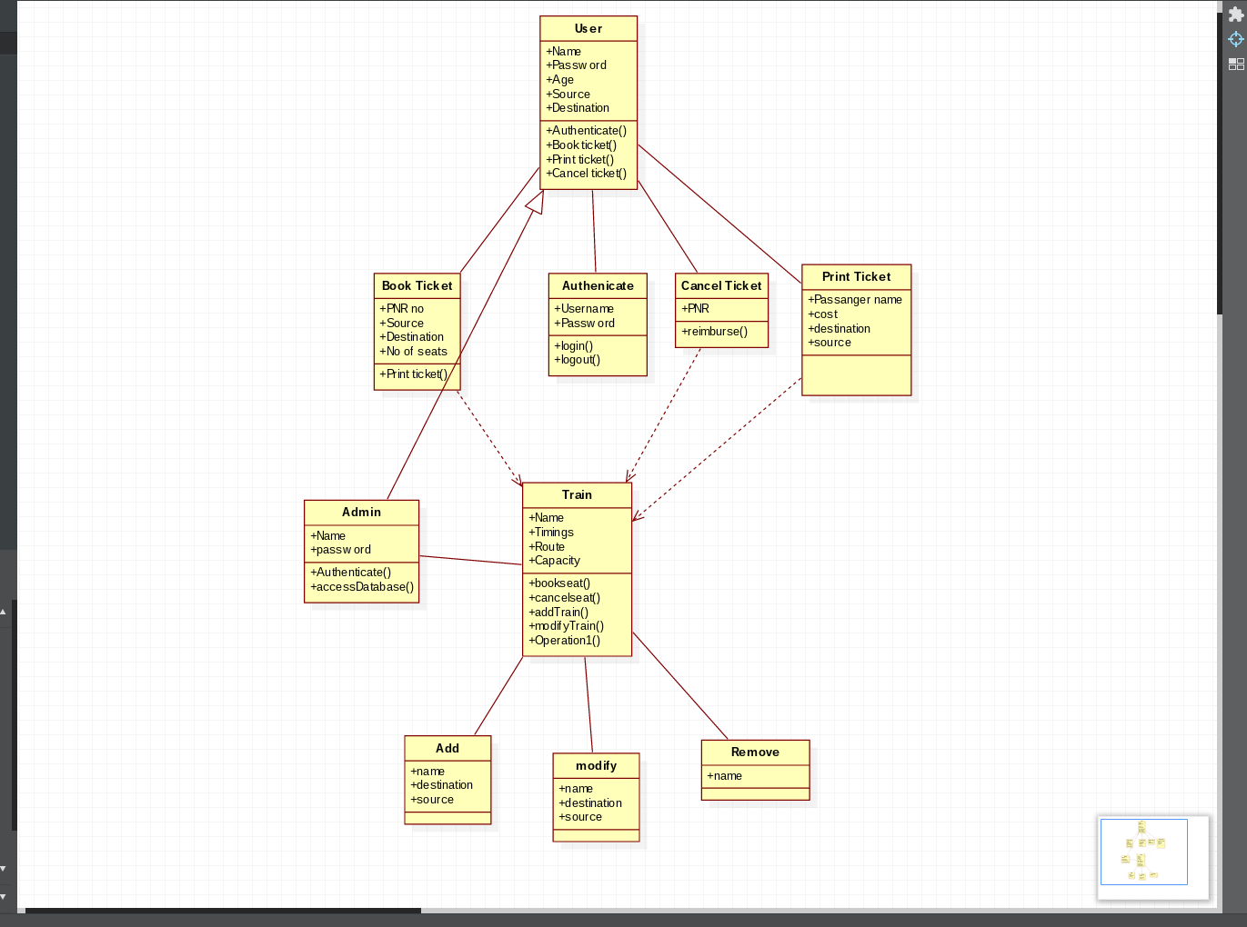

Functionalities of the classes used
Usecase name | Explanation
Check Ticket Availability  Pay fare amount  Book ticket  Fill out personal details  Cancel ticket  Refund money | Used to check ticket availability from the railway database  Traveller pays the amount and saves it in the database  After paying the amount,the traveler shall be able to book the ticket.Hence use case of pay fare amount is included in book ticket  The traveler fills out the personal details after choosing the option of booking ticket  Used to cancel the ticket and the database is updated  Used to refund money and updated in the database

Result
The class diagram for on-line railway reservation system is completed and verified.

